3. Water Jug Problem
AIM:
To solve the Water Jug Problem using Python by obtaining the required amount of water through a sequence of fill, empty, and transfer operations.

Objective:
- To understand the Water Jug Problem.
- To implement the solution using Python.
- To achieve the target quantity of water using the given jug capacities.

Algorithm:
- Start.
- Initialize Jug1 (4 L) and Jug2 (3 L) as empty.
- Fill Jug2 completely.
- Pour water from Jug2 into Jug1.
- Fill Jug2 again.
- Pour water into Jug1 until Jug1 becomes full.
- Empty Jug1.
- Transfer the remaining water from Jug2 to Jug1.
- Fill Jug2 again.
- Pour water from Jug2 to Jug1 until the required quantity is obtained.
- Display the result.
- Stop.
Flow Chart:
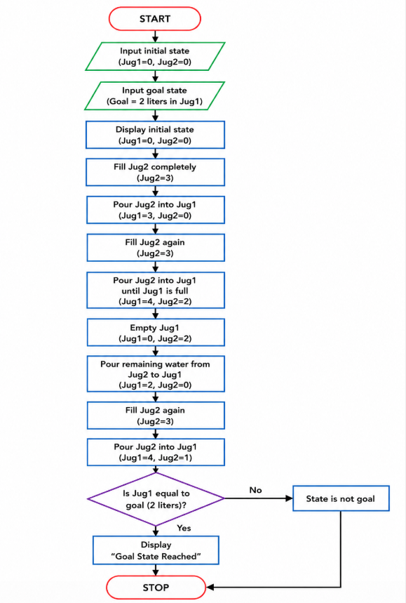
Coding:
jug1 = 0
jug2 = 0

capacity1 = 4
capacity2 = 3
goal = 2
jug2 = capacity2
transfer = min(jug2, capacity1 - jug1)
jug1 += transfer
jug2 -= transfer
jug2 = capacity2
transfer = min(jug2, capacity1 - jug1)
jug1 += transfer
jug2 -= transfer
jug1 = 0
transfer = min(jug2, capacity1 - jug1)
jug1 += transfer
jug2 -= transfer
if jug1 == goal:
print("Goal Achieved! Jug1 contains", goal, "liters.")
else:
print("Goal Not Achieved")

Output:
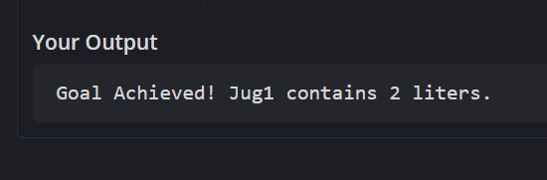
Result:
Thus, the Water Jug Problem was implemented successfully and the goal state was achieved.

